# Startup

Startup 1

Startup Performance 2

UEFI Support 3

UEFI Overview 4

UEFI and Windows 8 5

Secure Boot 7

Early-Launch Anti-Malware 8

Measured Boot 8

New Boot Menu 9

Accessing the Startup Menu 9

Automatic Repair Offered 10

Boot from Installation Media or a System Repair Disc 10

Accessing the Boot Menu Manually 11

Startup Options 14

Accessing Additional Startup Settings 16

UEFI Options 18

Lab: Startup 20

Exercise: Startup 20

#### Timing for This Module

|  |  |
| --- | --- |
| Delivery Length: 45 Minutes | Additional Lab Time: 45 Minutes |

#### Overview

This section of the training discusses some of the changes to startup in Windows® 8. This includes hardware support changes that are important to the startup process.

Changes were made in the following categories:

* Improved startup performance
* Unified Extensible Firmware Interface (UEFI) Support
* Secure Boot
* Early Launch Antimalware (ELAM)
* Measured Boot
* New Boot Menu

Each of these changes is discussed in more detail in this section of the training.

## Startup Performance

Recent Microsoft® Windows releases have increasingly offered sleep and hibernate power states as a recommended alternative to a full shutdown and startup. Hibernate in particular generally brings the computer up and ready for use more quickly than a cold boot.

Many customers still prefer to shut down their computers. This can be due to a preference of having a new user session on the next startup, or to save power compared with the sleep state.

In Windows 8 there are improvements to make the shutdown/startup and restart processes faster. These improvements also bring increased speed to the resume from hibernate.

#### Old Shutdown Steps

When you shut down a computer running Windows, this is the typical sequence of events:

1. Click **Shut down**.
2. Windows broadcasts messages to running applications, giving them a chance to save data and settings. Applications can also request a little extra time to finish what they are doing.
3. Windows closes the user sessions for each logged on user.
4. Windows sends messages to services notifying them that a shutdown has begun, and subsequently shuts them down. If a service doesn’t respond, it is shut down forcefully.
5. Windows broadcasts messages to devices, signaling them to shut down.
6. Windows closes the system session (also known as “Session 0”).
7. Windows flushes any pending data to the system drive to ensure it is saved completely.
8. Windows sends a signal via the ACPI interface to the system to power down the computer.

#### New Hybrid Shutdown

Windows 8 changes this by shutting down as far as closing the user sessions. At that point, instead of continuing and ending system services, and shutting down Session 0, Windows then hibernates. This is called Hybrid Shutdown. The steps are shown below.

1. Click **Shut down**.
2. Windows broadcasts messages to running applications, giving them a chance to save data and settings. Applications can also request a little extra time to finish what they’re doing.
3. Windows closes the user sessions for each logged-on user.
4. Hibernate the Windows session.

Essentially a Windows 8 shutdown consists of logging off all users and then hibernating.

#### Startup Is Now Faster

This results in a significant reduction in startup time. It’s faster because resuming the hibernated system session is comparatively less work than doing a full system initialization. It is also faster due to improvement in the resume process, which now uses multiple CPU cores in parallel to process the hibernation data file, where previous Windows versions used only one.

Hardware is still enumerated fully in this new startup behavior, and drivers are still fully initialized. This helps ensure that a shutdown and startup can still result in a good hardware state if you are performing these steps as a cold boot for troubleshooting purposes.

#### How to Perform a Full Shutdown

If you want to shut down the computer without using the Hybrid Shutdown behavior, you can use Shutdown.exe to shut down the computer. Full shutdown is the default when you use Shutdown.exe.

Shutdown /s /t 0

The Shutdown.exe command also includes an optional /hybrid parameter that can be used if you want to use the new method.

#### What About Restart?

When you restart the computer, that typically means that you want a completely new Windows state, either because you have installed a driver or replaced Windows elements that cannot be replaced without a full restart.

As a result, the restart process in Windows 8 continues to perform a full boot cycle, without the hibernation performance improvement mentioned above.

## UEFI Support

While Windows has had support for the Unified Extensible Firmware Interface (UEFI) prior to Windows 8, most consumer computers have continued to boot using BIOS firmware.

This changes with Windows 8, as UEFI firmware mode is now a Windows 8 client logo requirement. UEFI is also required to enable several features and improvements, such as:

* **GUID Partition Table (GPT) disk partitioning** - GPT partitions enable larger partitions, and are supported by UEFI.
* **Boot from large disk drives** - GPT and native 4K sector disk support in Windows 8 enables support for >2.2 TB boot drives.
* **Secure Boot** - Signature checks on early boot components, helping to protect pre-boot manager components from tampering.
* **Measured Boot** - Works with the TPM to log startup components and activities.
* **Early Launch Anti-Malware** - Registering and loading an anti-malware driver as a trusted boot-critical driver to help protect the system earlier in the boot process than with previous architectures.
* **Trusted Boot** - A combination of Secure Boot, Measured Boot and Early Launch Anti-Malware that helps establish that the system is in a trusted state.
* **Boot on computer with no VGA Support** - UEFI removes the need for VGA support, enabling Windows 8 to be installed on computers that do not use this legacy video technology.

Some of these features are targeted for use in a business setting, so they are not covered in this consumer-focused training. Instead, we will examine UEFI support in general, and any support considerations for UEFI enabled computers in a consumer setting.

### UEFI Overview

Windows support for UEFI was first introduced in 64-bit editions of Microsoft Windows Server® 2008 and Windows Vista® Service Pack 1. Windows 7 and Windows Server 2008 R2 continued to support UEFI. The main reason for early adoption was for GPT and large boot disk support.

Many computers built prior to Windows 8 took advantage of UEFI architecture to reduce costs and standardize firmware stacks, but were still used in BIOS mode to remain compatible with existing factory processes, tools, legacy operating systems, drivers, option ROMs, and some applications. These UEFI computers are called “Class Two” UEFI as defined by Intel. This means that they have the capability to boot into native UEFI mode, but in practice most computers boot into legacy BIOS mode using a Compatibility Support Module (CSM). The figure below demonstrates boot flows for Class 2 systems.

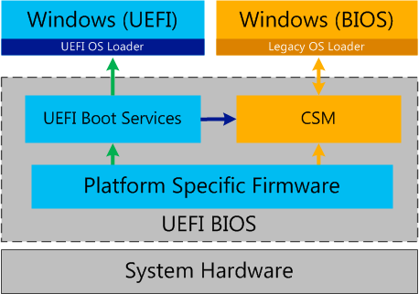

Figure : UEFI Startup Paths

The gold elements in the diagram indicate legacy BIOS-style startup. The green arrows show native UEFI mode boot. The blue arrow indicates a system that attempts to boot into UEFI mode to an OS that does not support it. UEFI configured with CSM enabled reverts the boot process to BIOS mode via the CSM. This is called “progressive boot.”

### UEFI and Windows 8

It is expected that there will be more Class 2 systems designed for use with Windows 8 that boot into native UEFI mode with the CSM disabled – this is represented by the crossed-out CSM path in the diagram below. This enables the use of Secure Boot, and compatibility with the Windows 8 Logo requirements.

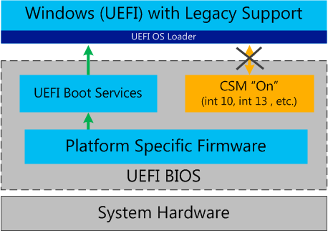

Figure : Native UEFI Mode with CSM support

So on a Windows 8 UEFI computer, there are three likely configurations:

* Computer with native UEFI startup. CSM is not used. Green arrows above.
  + Improved Boot Performance: Yes
  + Secure Boot: Yes
* UEFI computer boots into native UEFI mode, but still loads the CSM for legacy device or OS support: Green arrows. Some interaction with gold component remains.
  + Improved Boot Performance: Some improvement vs. BIOS configuration
  + Secure Boot: Yes
* UEFI computer boots via the CSM into BIOS mode: Boot via legacy path shown in Figure 1.
  + Improved Boot Performance: No improvement
  + Secure Boot: No

#### Architecture Requirements

One new requirement introduced with UEFI native boot support is that it uses a specific bit-ness. This means that a UEFI 32 firmware core must be used to install a 32-bit OS and likewise UEFI 64 for a 64-bit OS. It is possible to have support for both 32-bit and 64-bit UEFI in one BIOS, but it requires additional work and ROM space, so this may not be commonly implemented.

This is only an issue in consumer scenarios if a customer wants to install a replacement or retail copy of Windows 8 on their OEM UEFI computer. In such a scenario, help the customer identify their current architecture (32-bit or 64-bit), and help direct them on a good path to reach their desired goal. They may need to contact the OEM in order to determine whether this potential limitation applies to their computer.

## Secure Boot

One of the benefits of a UEFI configuration is that it supports signing and verification for UEFI executables, up to and including the boot manager, which implements the boot menu in Windows.

This, combined with further verification checking done by Windows, is what constitutes Secure Boot. This feature helps protect Windows against malware or other tampering.

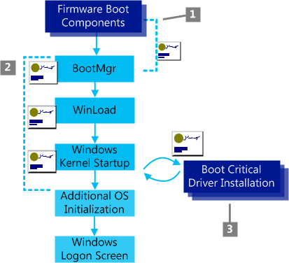

Figure : Secure Boot

The three main actions related to Secure Boot are shown in the diagram above. These are:

1. The firmware verifies all UEFI executables and the OS loader to be sure they are trusted.
2. Windows Boot Components verify the signature on each component to be loaded. Any non-trusted components will not be loaded and will trigger remediation.
3. The signatures on all Boot Critical Drivers are checked as part of Secure Boot verification in WinLoad and by the Early Launch Anti-Malware driver

#### Secure Boot Remediation

In the event that the UEFI firmware that Boot Manager does not match its signing information, it replaces Boot Manager with a backup copy. In the event that this also fails, the UEFI firmware will display some kind of remediation information, giving you a way to return to a trusted state. This remediation experience is implemented by each OEM, so the specifics differ.

## Early-Launch Anti-Malware

Secure Boot enables a related feature: Early-Launch Anti-Malware (ELAM). This provides the ability for an anti-malware driver to register as a trusted Boot Critical Driver. This makes it the first non-Microsoft, non-platform specific code that will run on the computer. The anti-malware driver can then verify other drivers in turn before they are initialized.

Secure Boot helps prevent malware from running before the OS, Early Launch AV helps ensure that trusted anti-malware software is the first third-party component run on each startup.

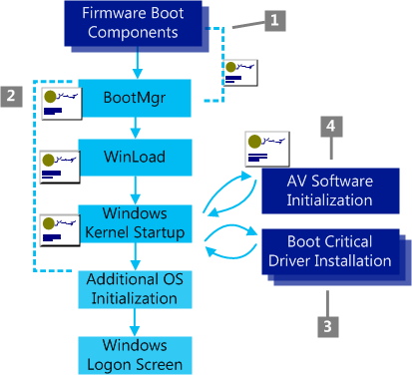

Figure : Secure Boot with ELAM

ELAM adds a fourth step to the Secure Boot process, labeled “4” in the diagram above.

* Early Launch Anti-Malware driver is checked for a special signature issued by Microsoft verifying that it is trusted and will early launch, meaning it is always started before all other drivers.

## Measured Boot

Measured Boot is another boot feature in Windows 8 that is also related to anti-malware software. Measured Boot gives the anti-malware software a detailed, reliable log of components that loaded prior to the anti-malware driver during startup. This log can be used by anti-malware software or an administrator in a business environment to validate whether there may be malware on the computer, or evidence of tampering with boot components.

## New Boot Menu

Windows 8 includes a new startup interface. This is designed to better support computers with no hardware keyboard. An example of this interface on a dual boot configuration is shown below.

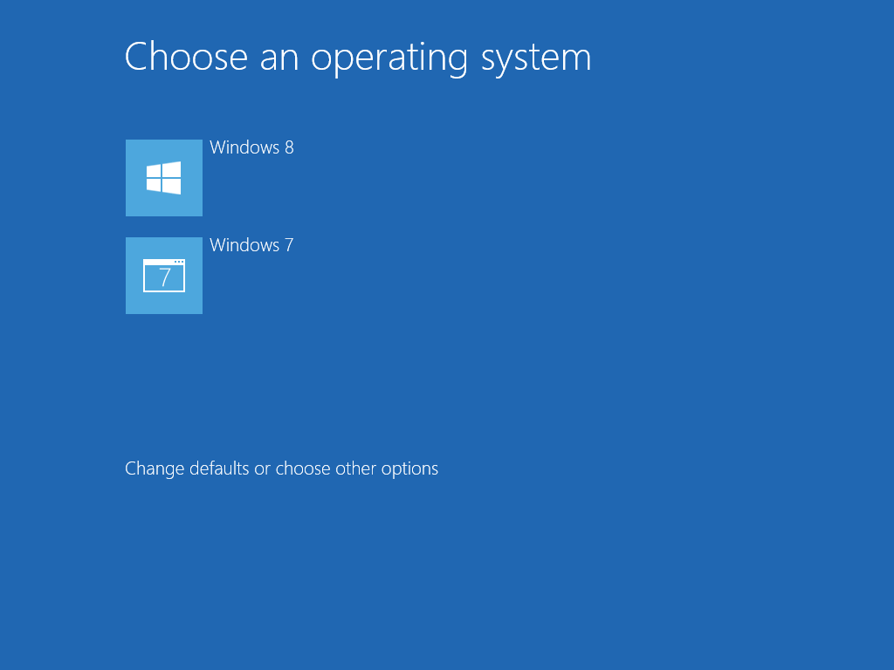

Figure : Boot menu

The **Change defaults or choose other options** link gives you access to additional startup options.

### Accessing the Startup Menu

There are three ways to access the Startup menu in Windows 8:

* Startup failure detection.
* Boot from installation media or a system repair disc.
* Manually access the boot menu.

This leaves one method used in Windows 7, which is no longer available, F8. The Windows 8 boot process no longer watches for the F8 key during startup.

Each of these topics is discussed in this section.

### Automatic Repair Offered

On most computers, you will only see the new boot menu in the event of a startup issue. Windows 8 automatically offers to provide repair options when there was an issue starting the computer on the previous startup.

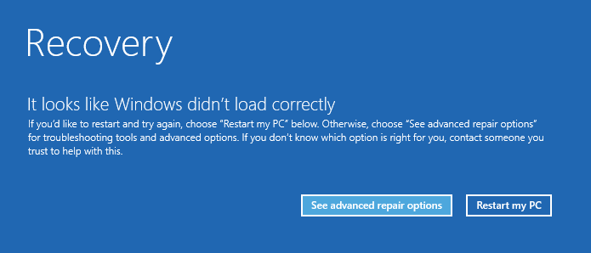

Figure : Startup Repair

When you click the **See advanced repair options** button, it opens the startup repair menu, which offers options for System Restore, Startup Repair, and other WinRE options.

What if you are having an issue too late for this detection process to offer the startup menu? Try removing power during startup to cause the system to fail earlier in the process.

What if startup is failing too early for this detection process to offer the startup menu? You may need to use an alternate method to force the startup menu, such as starting from installation media.

### Boot from Installation Media or a System Repair Disc

If you have access to a Windows 8 installation DVD or USB flash drive, you can get to the Startup menu. Make your choice on the Language selection page, and then click **Repair your computer** on the first step of Windows Setup, shown below.

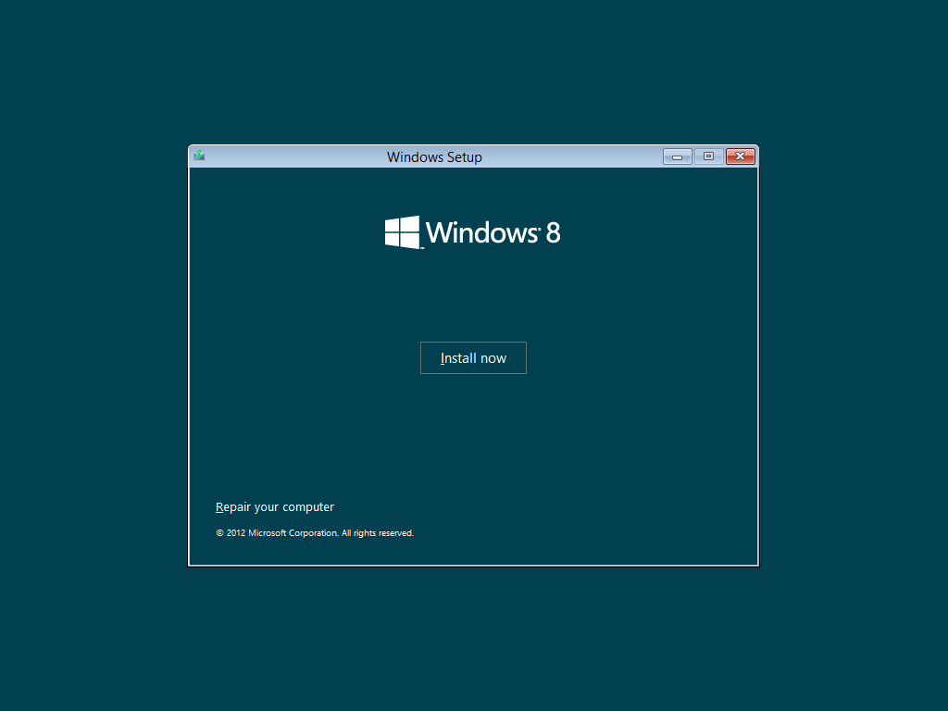

Figure : Windows Setup

This starts the option to continue and start Windows, or access troubleshooting tools, as shown in the Startup Options topic later in this module.

### Accessing the Boot Menu Manually

In the event that you need to access the boot menu when a failure has not been detected, you cannot use F8 as on previous Windows versions. Windows 8 no longer listens for this key during startup. This change was made to further improve startup performance – waiting for this key press on every startup was creating a startup delay, and was becoming increasingly difficult to trigger, as the delay has been decreased in recent Windows releases to reduce boot time.

**Important:** F8 is no longer used to show the boot options! Use one of the methods below.

You can access the boot menu manually using any of the following methods:

* Shut Down menu
* PC Settings
* Command line

#### Shut Down Menu

You can perform this same type of restart from the **Power** option in the Settings charm. If you hold down the Shift key while clicking **Restart**, Windows 8 goes through the same sequence of events as if you had used **Advanced Startup** fromwithin **PC Setting**. Since you can open the **Shut Down** menu from any part of Windows 8 using the Settings charm, this is an especially quick way to directly reach the boot options menu.

[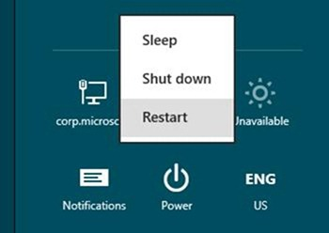](http://blogs.msdn.com/cfs-file.ashx/__key/communityserver-blogs-components-weblogfiles/00-00-01-29-43-metablogapi/4201.6_2D002D002D00_Shutdown_2D00_menu_5F00_1BA8169B.jpg)

Figure : Power

This option is available when using the restart option from the login screen as well. This can be helpful if you are troubleshooting an issue that happens after login.

#### Configure Startup to Use the Menu

Another method of reaching the boot options is from **Advanced startup** on the **General** tab of **PC Settings**. You can get to PC Settings from the Settings charm, or by searching from the Start screen using specific search terms, such as “boot,” “startup,” “safe mode,” “firmware,” “BIOS,” or several others.

The Advanced startup option is shown below. Click this **Restart now** button to start into the menu.

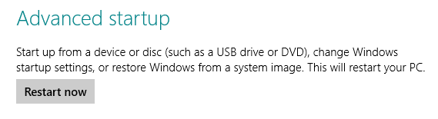

Figure 9: Advanced startup option

Pressing the **Restart Now** button begins the restart process. Then, just before Windows has finished shutting down and is about to fully restart and enter the BIOS POST process, the restart is paused and the boot options menu fades into view.

Providing the menu at this point in the restart is particularly useful on UEFI computers, where the menu can provide options for entering firmware setup directly.

You can also choose one of the other options in the boot menu at this point, restarting into an alternate OS or repair/recovery options very quickly.

#### Command Line: Shutdown Command

Another method you can use to access the startup menu is running the following command while in Windows:

Shutdown /r /o

This performs the same action as the two user interface options above.

#### Manually Enabled Boot Menu

Another option to access startup options is to enable the boot menu in the Boot Configuration Database (BCD). You can do this by setting the **displaybootmenu** option on the Boot Manager BCD entry. A BCDEdit command to accomplish this change is shown below.

Bcdedit /set {bootmgr} displaybootmenu yes

This option enables the older text-based Boot Manager menu, where you can use F8 as before to access startup options. Pressing F8 on the old style Boot Manager menu will display the startup settings interface, shown in the figure below.

To disable the option later, run the command with **no** at the end, rather than with **yes**.

#### What’s Missing? F8

Windows has been tuned with each version to start up more quickly, and pause for less and less time for user input to display boot options. In Windows 7 this is difficult to time. On Windows 8 it would have been even more difficult and potentially frustrating. Add to that the fact that every Windows 8 computer would need to pause for that input on every startup when F8 is seldom used.

As a result, the F8 boot menu trigger is no longer in the product. You must use one of the other methods if you want to access the startup menu.

### Startup Options

When you access the startup menu using one of the methods above, you will typically see the options shown below.

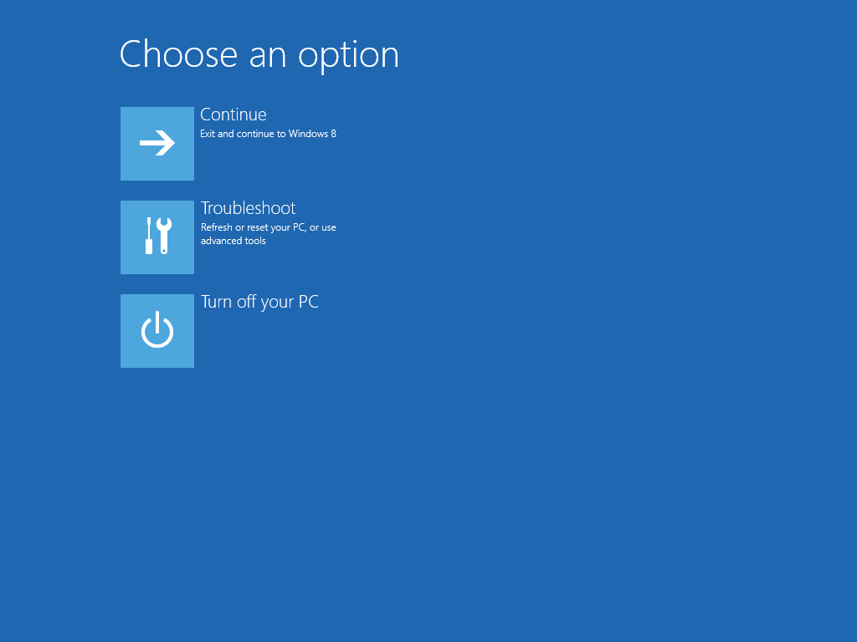

Figure : Startup Options

This is where you may see additional options as well, depending on your configuration:

* **Use another operating system:** Shown on dual-boot computers.
* **Use a device:** Shown on UEFI computers. Provides access to select the boot device.

Clicking the **Troubleshoot** option gives you access to the **Troubleshoot** interface, shown below.

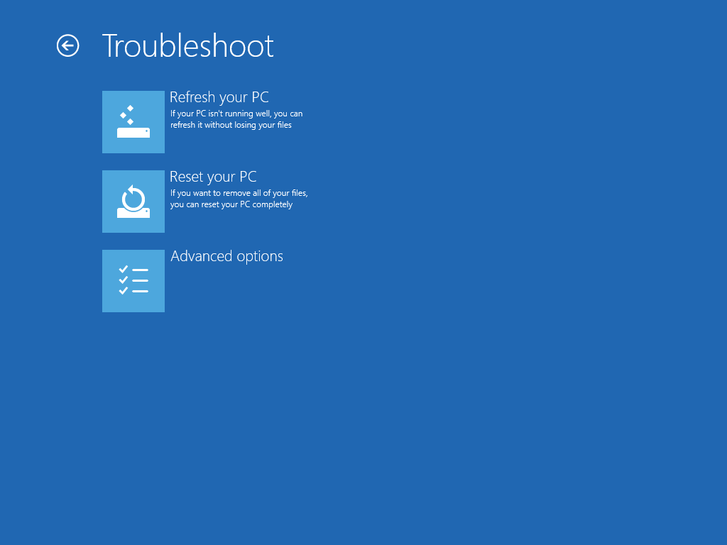

Figure : Troubleshoot Menu

Clicking the **Advanced options** option gives you access to the **Advanced options** interface, shown below. This includes the Startup Settings option when you access the startup menu from the hard drive. If you access the menu using media the option is not shown.

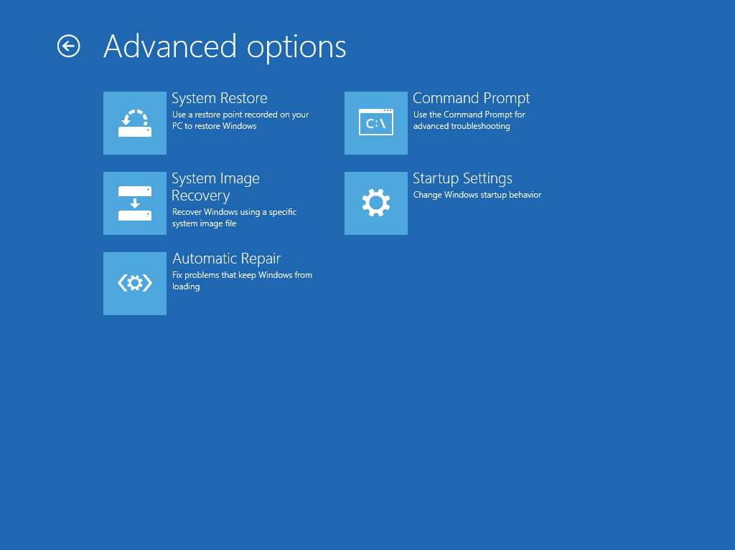

Figure : Startup advanced options

**Note:** For a UEFI system, this interface may have additional options, as shown in the UEFI Options section below.

### Accessing Additional Startup Settings

You may find that you need to access additional startup settings, such as disabling an early-launch anti-malware driver, disabling automatic restart on system failure to see an error message, or some other setting previously available by pressing F8 during startup. These options are provided via the Startup Settings interface, shown below.

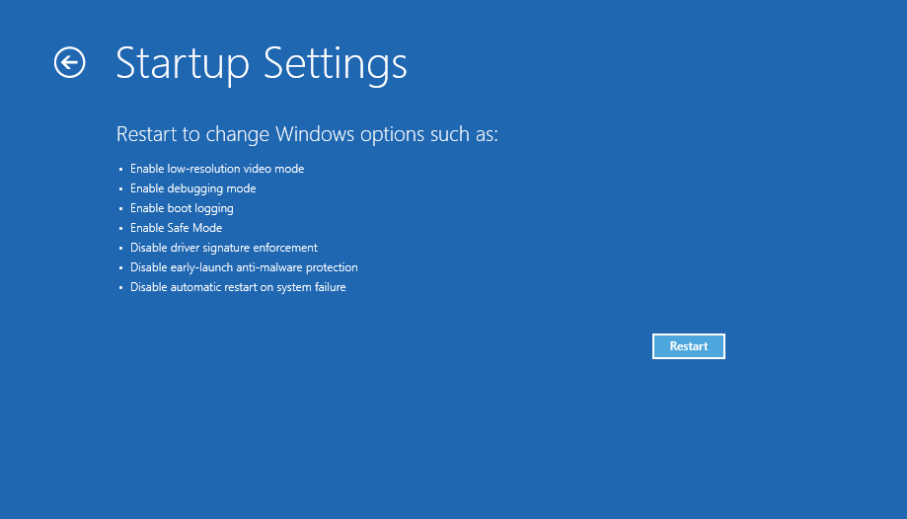

Figure : Startup Settings

Pressing the **Restart** button causes Windows to restart into the replacement for the F8 startup interface, shown below.

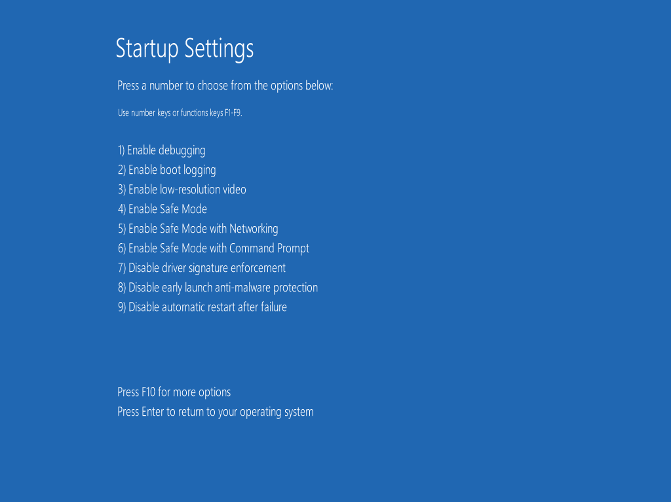

Figure : Startup Settings

The F10 key is used to change between two pages of options. By default, the second page has only one option – to press 1 to **Launch Recovery Environment**. This starts the WinRE interface, which is shown in more detail in the Recovery and Troubleshooting module of this course.

### UEFI Options

When you are running Windows 8 on a computer in UEFI native mode startup, you will also have options to select the boot device and enter firmware setup. These are options that on a BIOS computer are only accessible in the BIOS POST input step. UEFI gives the OS the ability to offer and access these options.

The boot device selection choice is shown on the main startup options step.

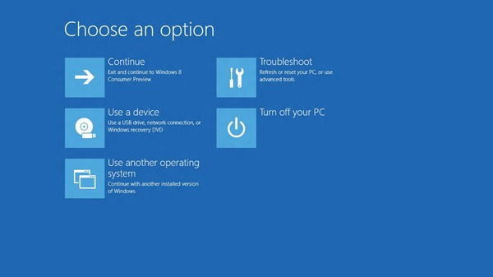

Figure : UEFI Startup Options

If you choose **Troubleshoot**, **Advanced options**, on a UEFI computer, you will also have an option to enter the UEFI firmware settings interface. The Advanced options interface with this option displayed is shown below.

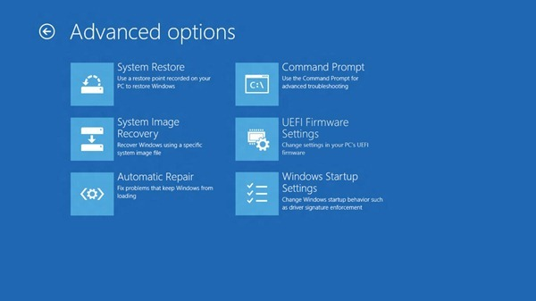

Figure : UEFI Startup Options Advanced

The two UEFI options above replace the steps on a BIOS computer where you might press F12 for boot device selection, or F2 to enter BIOS setup. This makes it much easier to help direct customers to perform the options, as the UEFI interfaces above do not depend on quick, timed keystrokes.

## Lab: Startup

This lab explores Windows 8 startup behavior and troubleshooting tools.

#### Expected Time for this Lab

This lab takes approximately 45 minutes to complete.

#### Requirements

To perform this lab, you will need the following:

* A PC with Windows 8 installed

### Exercise: Startup

1. Compare the time required to perform each of these actions on your computer:
   1. Shut down Windows, then start Windows.
   2. Restart Windows.
2. Was there a difference in the time required? Was this consistent with your neighbors in the classroom?
3. Working with your partner, start your two computers to the Startup menu using different paths. Compare the menu on both computers to find differences.
   1. Computer 1: Use the Advanced Startup option in PC Settings.
   2. Computer 2: Boot from Windows 8 media, if available.
      1. If you do not have media, configure a second startup entry in the Boot Configuration Database (BCD) that points to your existing Windows 8 installation. This should cause Windows 8 to display the Startup menu.
4. Are there any options available via one path but not the other? If so, what options and which path?
5. Is there any way to edit the boot configuration in either Startup menu version?
6. Restart both computers and try to trigger the Startup menu using startup failure detection by interrupting startup. Pull power to your computer at various points during startup.
7. How many times did you try this before you got the menu?
8. When you get to the menu, use each of the following troubleshooting tools to explore changes in their interfaces compared with Windows 7:
   1. Automatic Repair
   2. System Restore
   3. Command Prompt
9. Note any differences you find, compared with Windows 7.
10. Discuss your findings with the class.